Practical Production Supporting Account: Music Video

This term I have been working in a group of three. The two others that were in my group were Yasmin Cige Moxamed and Bradley Benton who were very hard working in the project as well as me Amina Musa. In our group we had to work on a music video, before making the music video we had to do a lot of research and we had to decide what type of song we wanted to do and what we wanted the theme and story to be about. As a group we had come up with a conclusion of doing the song “Rockstar” and the artists of this was “Nickleback.” We had decided to do this song because it had a good meaning to it, and it suited the kind of story we wanted the song to be based around.
A music video is a short clip or film that is normally joined by a complete piece of music/song. A music video usually has a storyline that fits in with the piece of music/song either to send out a message to the audience or to engage the audience with the song/music. Conventions of a music video are vital because without conventions the audience won’t know what’s going on in the video or what message the audience are meant to receive. Music genres are RnB, rock, hip hop, pop and many more. Music videos are/can be broken into various sub-genres
Narrative – This type of music video must include a beginning, middle and an end it is usually based on a simple story for example love.
Dance performance which includes an individual or a group of people dancing in the video.
Live performance –These types of music videos are a band performing a live performance they often lip sync this is a very common convention.
Surreal – These types of music videos have many special effects. Surreal videos have dream like quality which makes it look very realistic.
Animated- This type of music video is an animated video which suggests its creativity.
Literal- These types of music videos are really simple and easy to understand because the conventions it’s made up from are easily understandable.

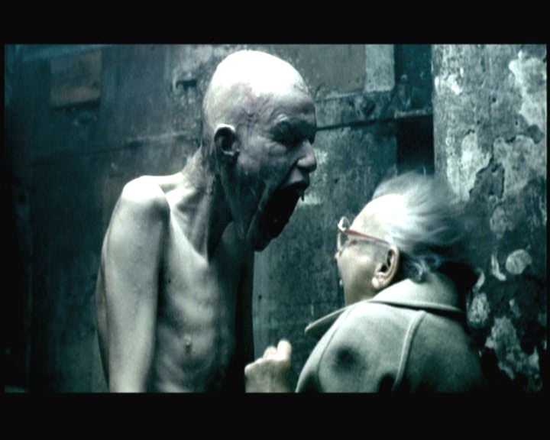Beforehand, we had to look at a various amount of music videos so that we would get an idea of how they work and what sorts of effects and things they use. One song that we looked into was “Papa Don't Preach" which is a song by Madonna. It was released in summer 1986 and reached number one in the United States, Australia and the UK, where it was the eighth biggest seller of the year. The song was written by Brian Elliot with additional lyrics by Madonna. The music video consisted of three different styles, one choreographed dance scenes, 2 home video footage scenes which made it look realistic. I think that this music video was very unique as it explored family life and it talked about how people change and I thought it was excellent. Another music video we watched was the famous music director Chris Cunnigham- “Come to Daddy” by Aphex twin. "Come to Daddy, Pappy mix" — often simply called "Come to Daddy" — is one of Aphex Twin's best-known songs. It opens with an old lady walking her dog. She comes across an old television, on which her dog urinates. This awakens a monster in the television, who commands children to do his bidding, such as trashing an alley and chasing a man into his car. The music video is sci-fi and it’s very unrealistic. I thought that the music video overall was good as it used a lot of different effects. It was very different from normal music videos and it stood out in its own way. Lastly the third music video we had also looked at was "Frozen" which is a pop song by Madonna from her 1998 album Ray of Light, written and produced by Madonna, Patrick Leonard and William Orbit. The song was released as a single in February 1998. The song was a huge success and is praised as being one of her best songs. Its success worldwide also marks it as one of Madonna's biggest ever hits. She appeared in the music video as a slightly Gothic appearance and it was very different from all her other videos as in the video everything was an unexplored territory for her. But I thought the music video was great because it was slightly different for her as she does not usually appear like that in a gothic way which makes the music video different and stand out.
The chosen song that I have chosen to relate to “Rockstar Nickleback” is “I believe I can fly” by R Kelly. I chose this song because its song that I feel boosts people’s confidence and motivates you to achieve your ultimate goals in life. The music video is very original and unique. "I Believe I Can fly" is a 1996 song by written by singer R. Kelly. The song was written, produced and performed by R. Kelly.
"I Believe I Can fly" was #2 on the Billboard Hot 100, #1 on the R&B Singles chart, and number #1 on the UK charts. The song also appears on Kelly's 1998 album R. It has won three Grammys, and is ranked #406 on Rolling Stone's list of the 500 Greatest Songs of All Time.
The song has been covered by Yolanda Adams, Me First and the Gimme Gimmes, Ruth Brown, James Ingram, William Hung, Ronan Keating and Ryan. “I Believe I Can fly" was performed by the school band in the movie Drumline during the high school graduation ceremony of Devon Miles
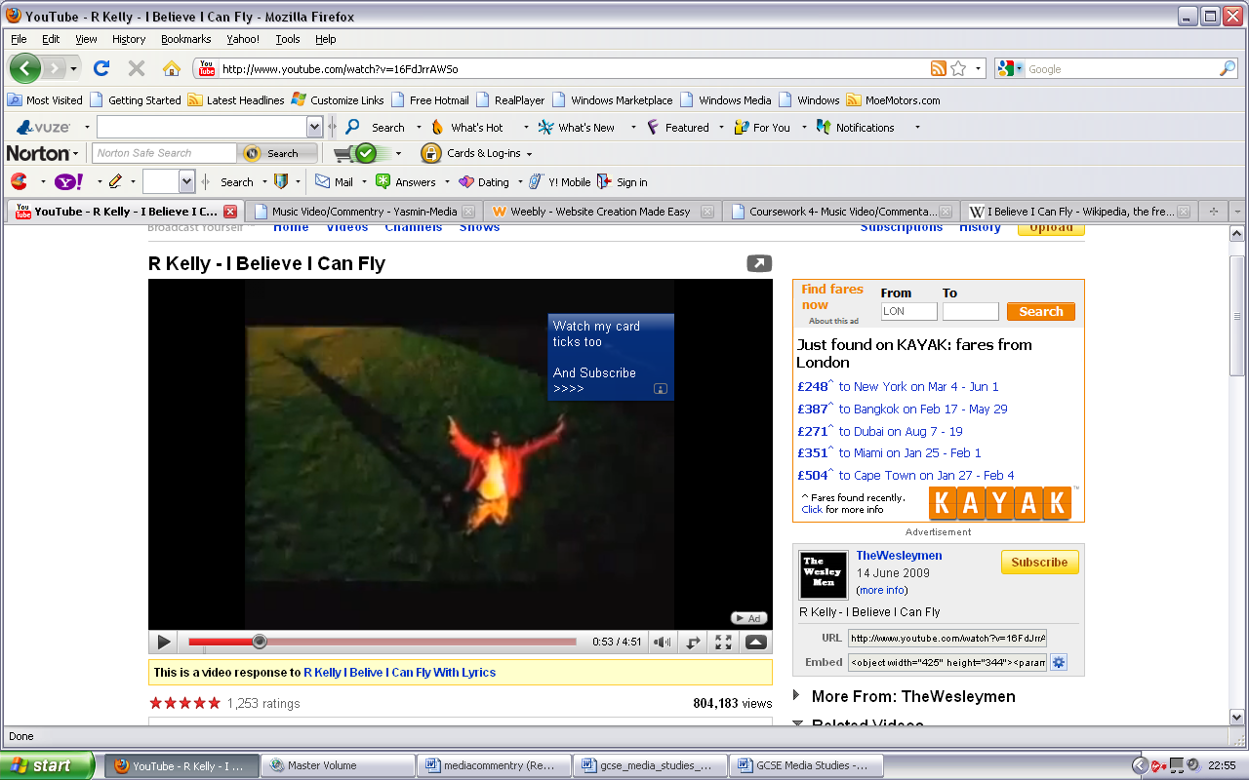
In my opinion I feel that the music video was represented in a positive way, because from listening to the lyrics and watching the music video it inspires you to fulfil your ultimate dreams and succeed them in life. The lyrics are very meaningful which relate to the public audience therefore more will be sold. I would say the target audience is for young adults and older adults but without doubt can relate to anyone who has a dream they would like to fulfil. The song without doubt has no fixed gender and can relate to male or female. Overall I would say the percentage would be 50% males 50% females. The affluence of the music video looks expensive but yet affordable due to the simple creativity used.
The process of making my music video was to research on our chosen song which was “Rockstar” written by Nickleback. "Rockstar" is the fifth U.S. single (although later re-released) by the Canadian rock band Nickelback from their 2005 fifth studio album All the Right Reasons. It was only released in the U.S. and Canada, and has since been re-released worldwide. "Rockstar" was a success in the United Kingdom, and the most successful single overall of Nickelback's career there, where it peaked at #2 in the UK Singles Chart and #1 in the UK Official Download Chart. The song was released in physical form in the country after becoming popular online and climbing into the top 50 on downloads alone. Over two years after the release of All the Right Reasons, it became the band's highest charting single in the country, beating the peak of their breakout hit, "How You Remind Me", which reached #4 in 2002 (though "How You Remind Me" remains slightly Nickelback's biggest selling single in the United Kingdom to date). The release of "Rockstar" also helped All the Right Reasons achieve a top 10 position in the UK Albums Chart for the first time, becoming their third top 10 album there. It also pushed sales of the album there from under 200,000 to over half a million. In the UK it was one of the biggest selling singles of 2008. The song remained on the UK Singles Chart for 50 consecutive weeks before falling off in October 2008, making it one of the most successful songs on the chart in years in terms of longevity. It fell out of the top 40 on 6 July 2008.
The type of music video genre my group and I had chosen was Narrative because the piece of music we chose called rockstar by Nickleback had a start, middle and end. The music genre was rock. As a group we sat down and discussed the storyline of our music video. Overtime we came up with a conclusion to do a storyboard of everything that was going to take place in our music video. Our target audience was going to be for young people aged between 14-19 because the storyline of our music video is a young boy who wants to be a rockstar but in the end his dreams are crushed and not fulfilled. This relates to young people because when you are aged 14-19 it’s usually the time when you struggle to make decisions in your life on what you want to grow up to be. Youth in my music video are portrayed in a confused manner, the believability of the music video is perfect because it represents youths positively today and how they are struggling to make there own decisions in life.
Producing the music video was a bit difficult as we had used new software’s on the apple Mac which we were not quite fond of using which made it difficult for me to use. I had used final cut pro which is a professional programme designed to make videos. Firstly we had conducted research. Then we had chosen our music video and made a storyboard based on the song. Next we had filmed for our project and then we put in onto computer. We spent about a month editing our project and adding in different effects and looking at more music videos to get more ideas of different effects. Whilst creating the music video we had encountered many problems like we did not know how to use the software as we had to get used to it. So we had to constantly asking our teacher but then towards the end we knew how to use the software properly so it was better but at first it was very difficult. Another problem we faced was the different effects and we did not know which one to use and which one looked better so we had to decide in our group properly of how to structure our music video and what scene would be in which bit. We had overcome this by changing and adding scenes in and we were testing which were best and which were worst and so we came to agreements.

The conventions we used in our music video were things that you would normally see in a rock genre music video. For example we used black and white effects, negative mode, sepia and many more. We also used a number of video transitions like swing and spin. My music video fits in with the rock genre because it contains the obvious, typical conventions you would see in rock genre. The use of blur represents the fact that it’s all a blur/ dream and is not reality.
The storyboard helped us a big amount, because it gave us guidelines that were vital to follow. It gave us a clear visual image of what the video was going to look like. As a group we benefited from the task a great deal because we know now how to use a camera properly, how to create a music video and most importantly what it means to have team communication. It was a huge challenge for myself and the group but finished in the end. We came across many problems but overcame them very quickly as we had a strict deadline to meet.
Overall I would give myself a 6/10 for music video this was due to the hard work our group put into the work, the challenge was hard but was completed in the end. Another reason I gave myself a 6/10 was because the song was very restricted and gave and did not give us much to do with the video. If I had the chance to do the music video again I would change the song and change the storyline. The bad things was all the editing as it was hard to get used to and think of the structure of the music video and we had to think a lot. The music video really helped me improve my skills and it helped me a lot even with my team building skills in media as this is the first project as we had worked as a group.
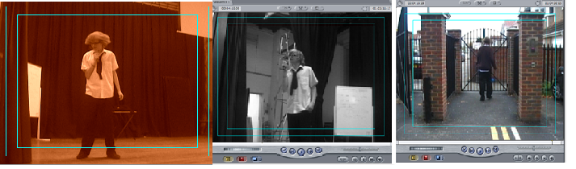Screenshots of my video

